Course Introduction Mar 26, 2026
This course focuses on essential skills for project, stakeholder, and requirements management, particularly for non-project management professionals.
Project Management Framework
- Understand the relevance of project management frameworks, including predictive, adaptive, and hybrid models.
- Recognize the roles non-project managers play in managing projects effectively.
Stakeholder Management
- Learn to identify and classify stakeholders using tools like stakeholder registers and RACI charts.
- Develop effective communication and engagement strategies to build stakeholder commitment.
Requirements Management and AI Applications
- Gain hands-on experience in eliciting and prioritizing requirements that align with business objectives.
- Explore how generative AI tools can assist in drafting questions, clustering feedback, and creating requirement documentation.
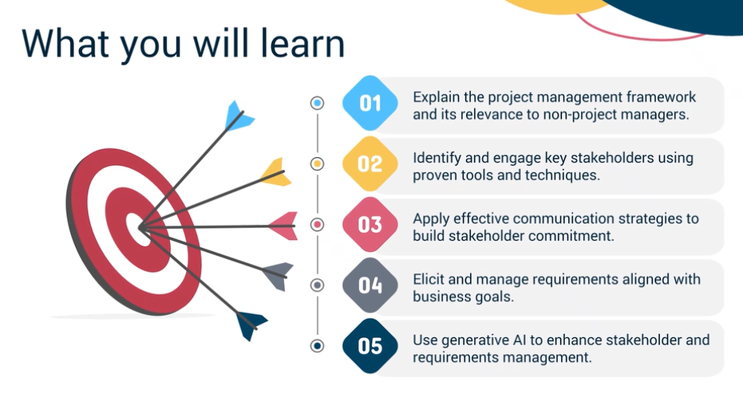
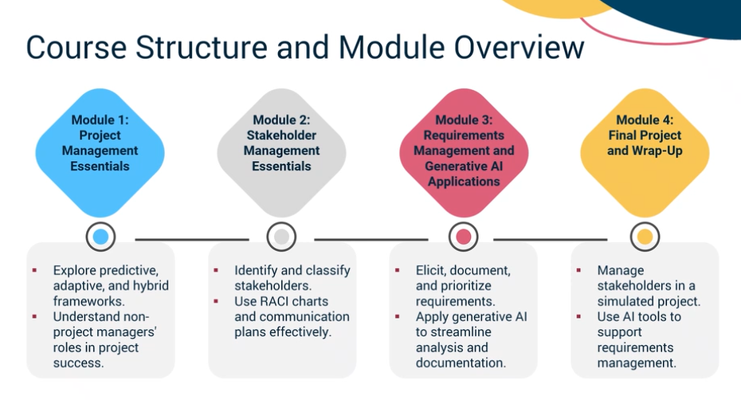

Introduction to Predictive Project Management Mar 26, 2026
This video lecture focuses on understanding predictive project management and the roles of project managers (PM) and business analysts (BA) in the project lifecycle.
Business Analysis Lifecycle
- Begins with needs assessment to identify business problems and objectives.
- Involves stakeholder engagement, elicitation of requirements, and tracking throughout the project.
Project Management Lifecycle
- Initiation defines the project's purpose and scope, securing approval through a project charter.
- Planning develops a comprehensive project management plan, followed by execution, monitoring, and closing stages.
Collaboration Between PM and BA
- PM and BA interact during initiation, planning, execution, monitoring, and closing stages to ensure project alignment with business needs.
- Both roles share responsibilities in stakeholder engagement, change management, risk identification, and quality assurance throughout the project.
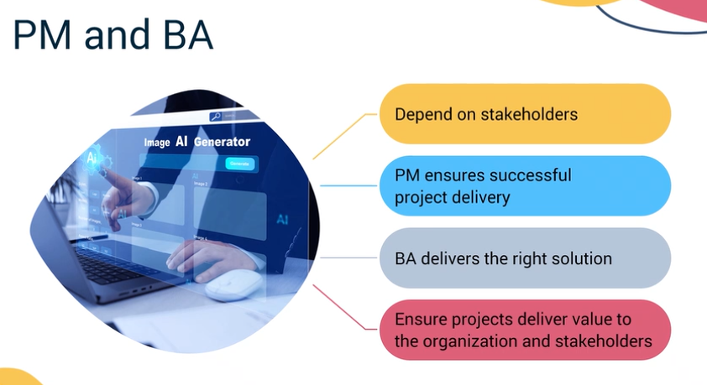

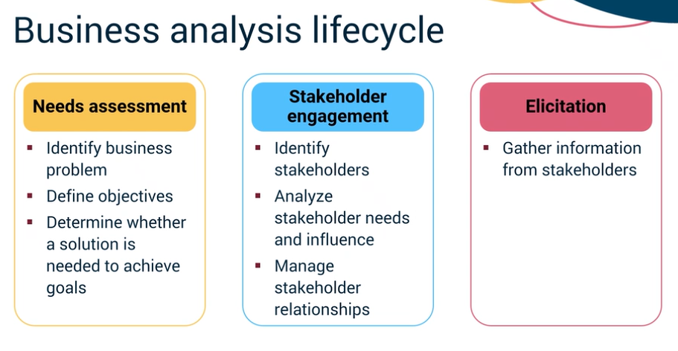
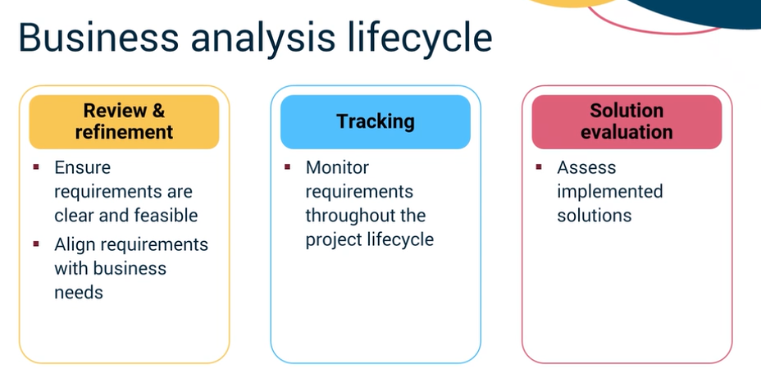

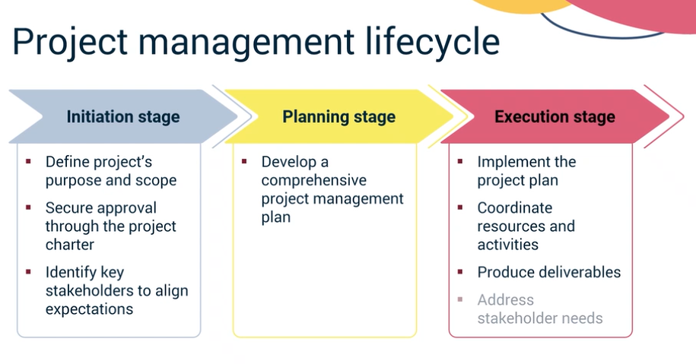
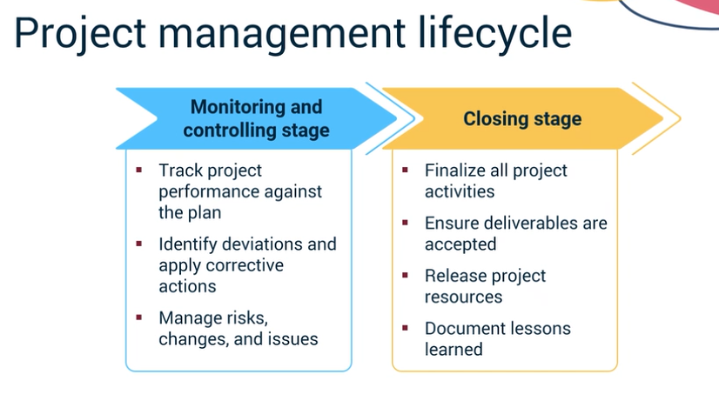
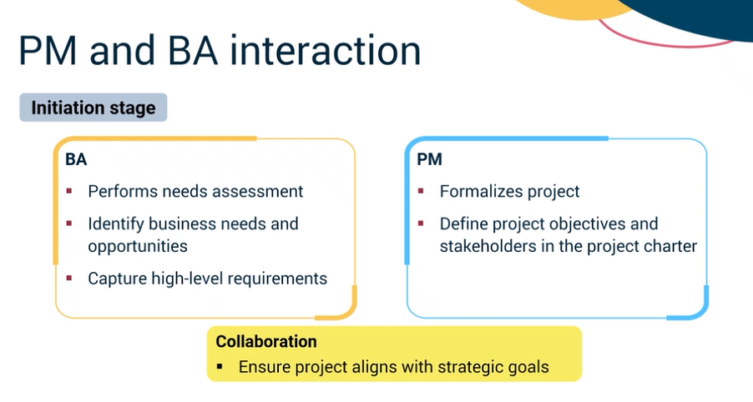
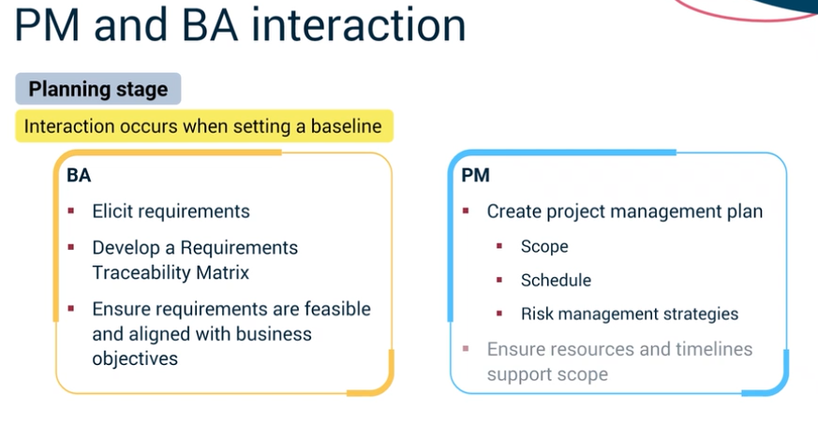

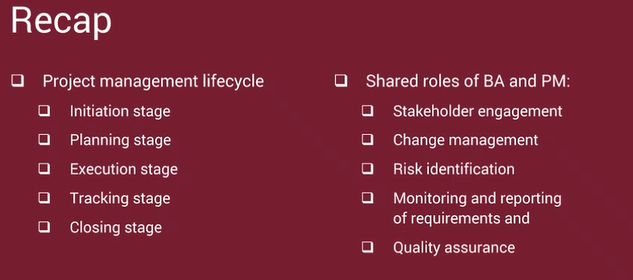

Predictive Project Management Framework: Key Activities Mar 26, 2026
This video lecture focuses on the key activities within the predictive project management framework, emphasizing the roles of both project managers and non-project managers in ensuring project success.
Predictive Process Groups
- There are five predictive process groups: initiating, planning, executing, monitoring and controlling, and closing.
- Each group plays a critical role in guiding the project towards success, with non-project managers contributing significantly.
Roles and Responsibilities
- In the initiating phase, the project manager (PM) leads the definition of the project, while non-PMs may help identify stakeholders and clarify needs.
- During planning, the PM sets the roadmap, and non-PMs can support by managing specific tasks within the Work Breakdown Structure (WBS).
Engagement Throughout the Project
- In the executing phase, the PM coordinates resources, and non-PMs may lead deliverables and perform quality assurance.
- Monitoring and controlling involve tracking progress and managing changes, where non-PMs can provide status reports and assist in quality control.
Project Closure
- The closing phase is led by the PM, with non-PMs participating in audits and providing feedback for lessons learned, ensuring a smooth transition of deliverables.
Overall, active engagement from non-project managers at each stage is crucial for delivering value and meeting stakeholder expectations.
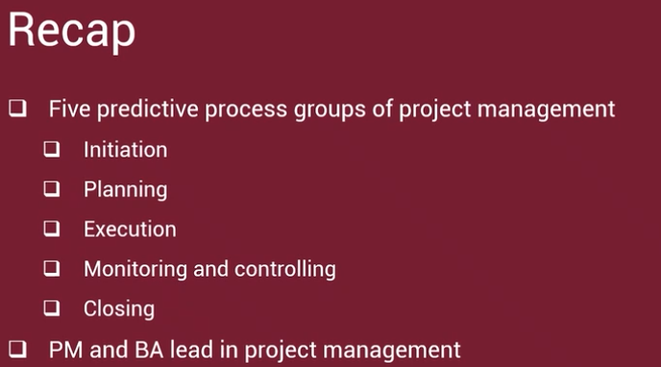

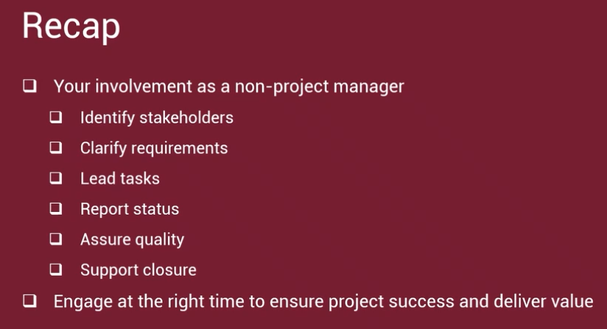

Areas of Involvement for Non-Project Managers Mar 26, 2026
This video focuses on the involvement of non-project managers in project management activities and how they can contribute to project success.
Key Activities in Project Management
- Business Case: Justifies the project by outlining expected benefits and aligning with organizational strategy. Non-PMs can provide data and identify needs.
- Project Charter: Authorizes the project and clarifies objectives and scope. Non-PMs may help define scope and clarify roles.
Critical Processes in Project Management
- Stakeholder Register: Identifies people affected by the project. Non-PMs can assist in identifying stakeholders and their needs.
- Requirements Elicitation: Gathers and documents stakeholder needs to prevent confusion. Non-PMs can share business rules or user needs.
Project Execution and Quality Assurance
- Work Packages and Tasks: Break down deliverables into manageable parts. Non-PMs may lead work packages or tasks.
- Quality Assurance and Control: Ensures processes are followed and deliverables meet quality standards. Non-PMs may conduct audits or checks.
Overall, the video emphasizes that non-project managers play a vital role in various project activities, enhancing the project's value through their contributions.
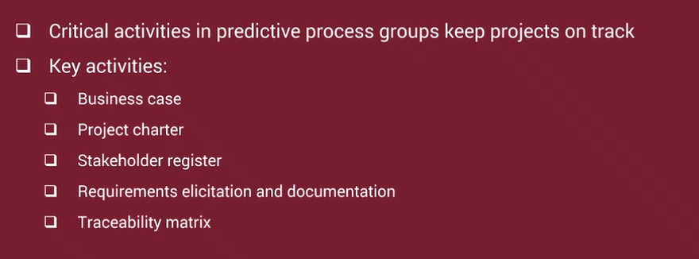
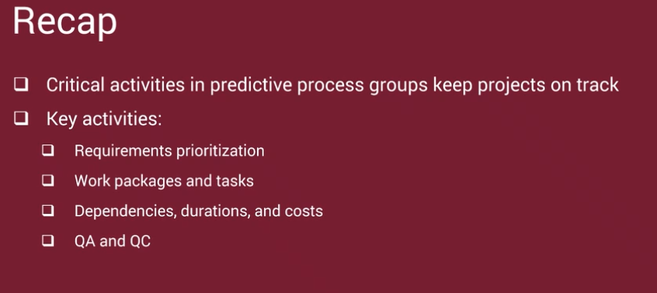
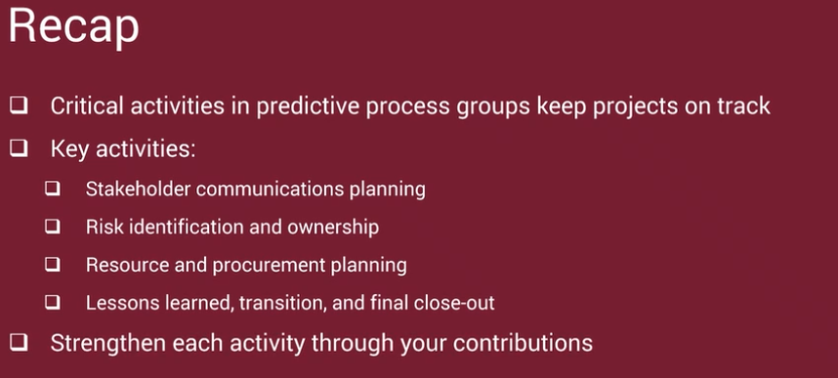

Introduction to Adaptive Project Management Mar 26, 2026
The video lecture focuses on Adaptive Project Management, specifically the Scrum process, which is a widely used Agile framework.
Scrum Framework Overview
- Scrum consists of five key events: Sprint, Sprint Planning, Daily Scrum, Sprint Review, and Sprint Retrospective.
- It includes three main artifacts: Product Backlog, Sprint Backlog, and Increment, which help in managing project tasks effectively.
Customer-Centric Approach
- The Scrum process begins with understanding customer needs, often through the creation of personas that represent typical users.
- A strategic roadmap is developed to guide the project, followed by creating epics and user stories that are prioritized in the backlog.
Sprint Planning and Execution
- Sprint Planning involves the Scrum Team, Product Owner, and Scrum Master, focusing on what work will be done during the sprint.
- Daily Scrums help the team stay aligned, while Sprint Reviews and Retrospectives allow for reflection and adjustment, ensuring continuous improvement and delivery.
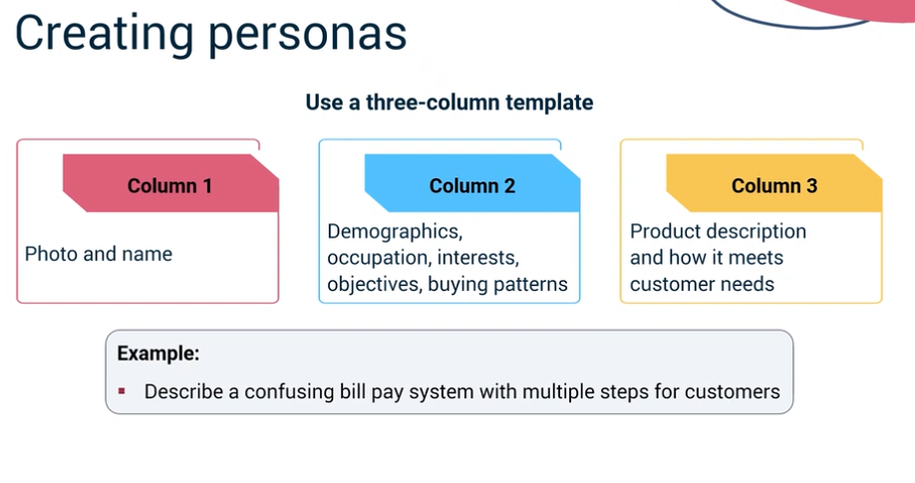
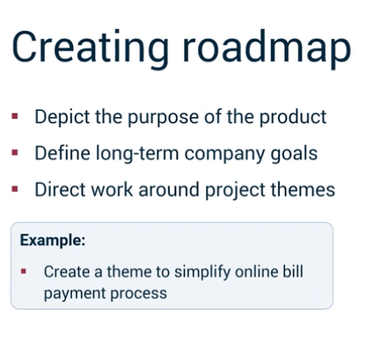
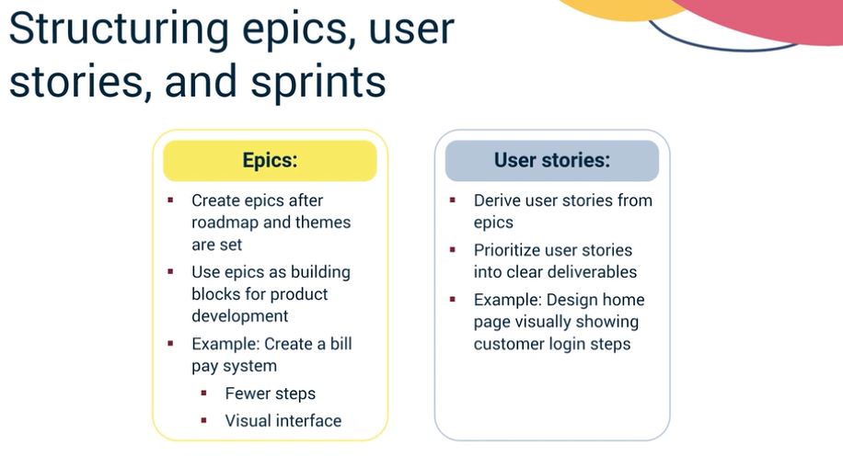
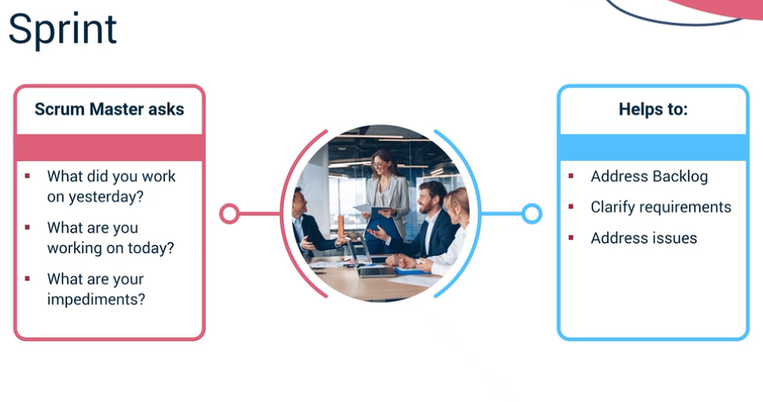
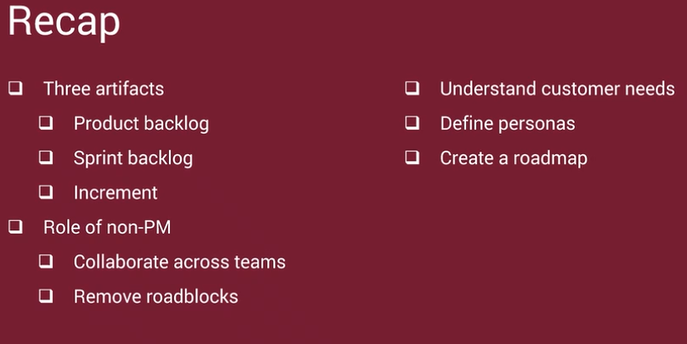
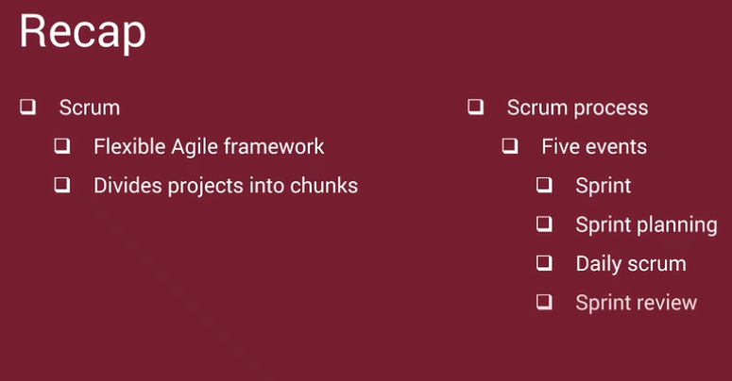

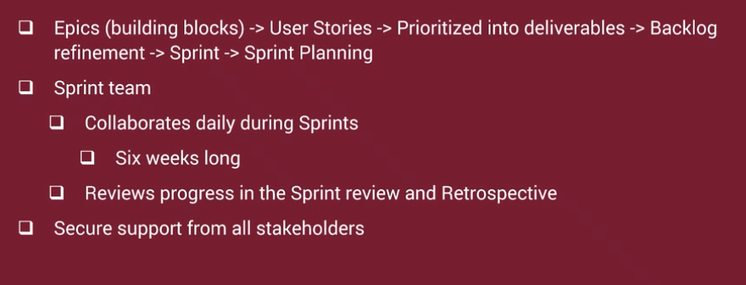

The Adaptive Project Management Framework Mar 26, 2026
The video lecture focuses on understanding "The Adaptive Project Management Framework" and highlights the importance of collaboration in Agile project management.
Key Roles in Agile
- The product owner (PO) translates the product vision into actionable scenarios, relying on input from stakeholders.
- The Scrum Master facilitates the process and helps remove impediments, while the development team builds the product incrementally.
Agile Activities and Processes
- Scenario development involves gathering insights from various stakeholders to ensure the product meets real needs.
- User stories are created to define user requirements, which are then prioritized in the product backlog through continuous stakeholder engagement.
Stakeholder Involvement
- Stakeholders play a crucial role in removing blockers during sprints and providing feedback during sprint reviews to ensure alignment with user needs.
- Broader organizational collaboration is essential for funding decisions and launch planning, impacting overall project success.
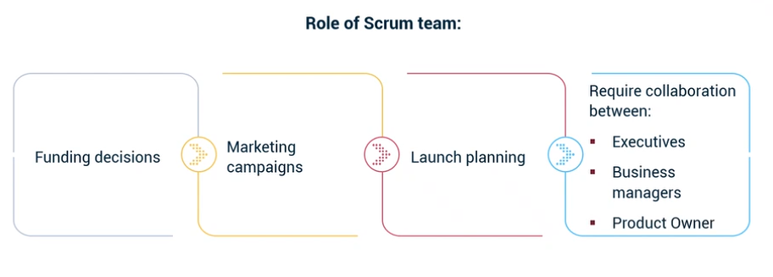
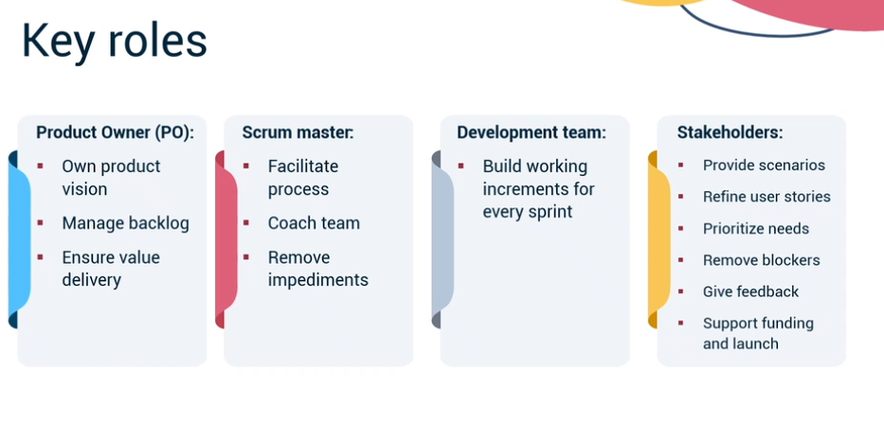
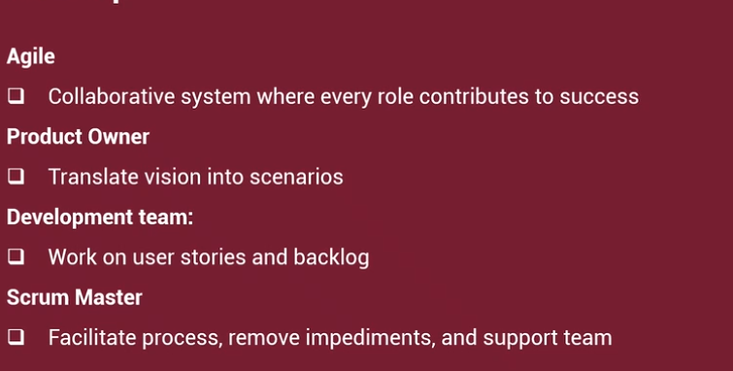
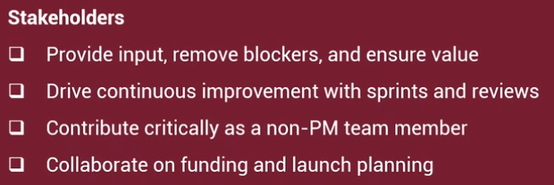

The Initiating Process Group: Your Involvement Mar 27, 2026
This video lecture focuses on the project initiation process, emphasizing the importance of creating a project charter and stakeholder register.
Project Initiation Overview
- The project initiation begins with developing a project charter and stakeholder register, requiring formal approval from the executive sponsor.
- The project manager (PM) leads the development of key documents, while the business analyst (BA) plays a crucial role in the pre-initiation phase.
Pre-Initiation Activities
- Step one involves identifying the problem or opportunity, where the BA collaborates with stakeholders to define the business need.
- The second step is assessing the current state, documenting strengths and inefficiencies to determine necessary changes.
Business Case Development
- The BA defines the future state by establishing business goals and objectives, and generates viable options through collaboration with stakeholders.
- A high-level business case is compiled, summarizing the problem, solution recommendations, and impact evaluation, which is then presented for approval.
Project Charter and Stakeholder Register
- Upon approval of the business case, the PM creates the project charter, formalizing the project's purpose and scope.
- The stakeholder register is developed to document key stakeholders' roles and responsibilities, serving as a critical resource throughout the project lifecycle.
Demo: Stakeholder Register Review Mar 27, 2026
The content focuses on the importance and structure of a stakeholder register in project management.
Stakeholder Register Overview
- A stakeholder register is a document that lists key stakeholders essential for project success.
- It includes details such as project name, individual stakeholder names or positions, and their organizations.
Roles and Responsibilities
- Stakeholders' roles are defined, and if not formally designated, their responsibilities are listed.
- The RACI methodology is used to clarify responsibilities: Responsible, Accountable, Consult, and Inform.
Document Management
- Comments can be added for more detail on specific roles.
- The register should include versioning and dates, as it evolves throughout the project lifecycle.
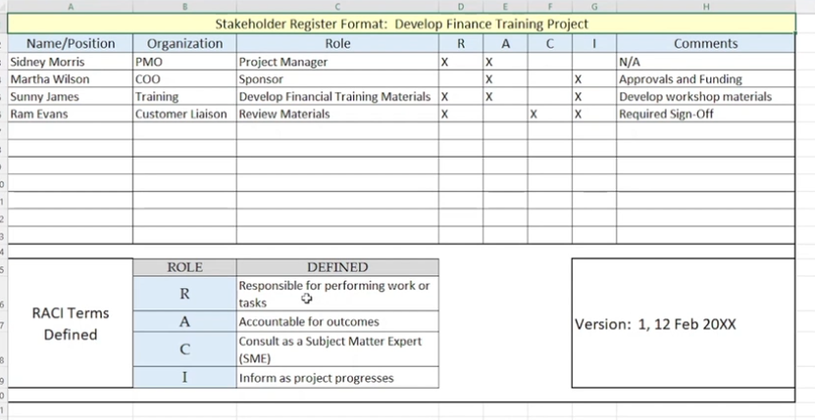

Demo: Stakeholder Identification: RACI Mar 27, 2026
The course content focuses on the RACI matrix, a valuable tool for stakeholder identification and project management.
RACI Matrix Overview
- RACI stands for Responsible, Accountable, Consulted, and Informed, clarifying roles in a project.
- It is useful for project managers, business analysts, and anyone coordinating teams or processes.
Application of RACI
- The RACI matrix can be applied in various settings, from project management to daily operations, ensuring clarity in responsibilities.
- Examples include defining roles in data engineering teams or customer service groups.
Benefits of Using RACI
- RACI enhances clarity, saves time, reduces conflicts, and builds trust among team members.
- It helps teams work more efficiently by clearly outlining who is responsible for each task.
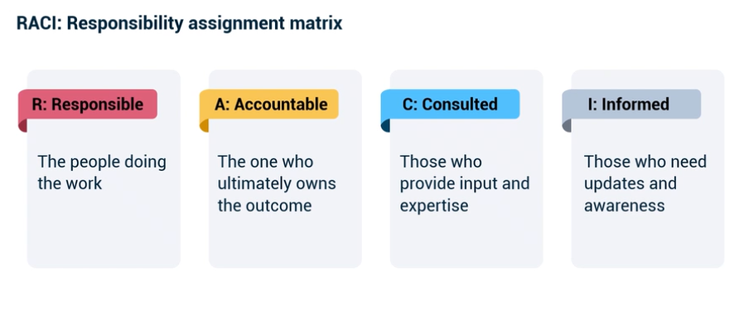
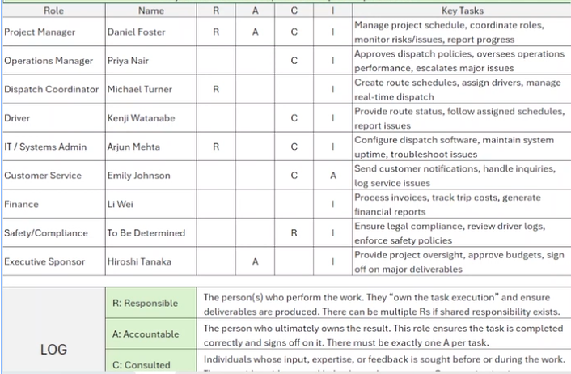

Stakeholder Classification Mar 27, 2026
This content focuses on stakeholder classification models that help in effective project management.
Power and Interest Model
- Stakeholders are categorized into four quadrants based on their power to influence the project and their interest in it: high power/high interest, high power/low interest, low power/high interest, and low power/low interest.
- Strategies for managing these stakeholders vary: key players need close management, while low power/low interest stakeholders require minimal communication.
Salience Model
- This model classifies stakeholders based on three attributes: power, legitimacy, and urgency.
- Stakeholders are categorized as definitive (all three attributes), dominant (power and legitimacy), dangerous (power and urgency), and dormant (one attribute). Each category requires a tailored engagement strategy.
Overall, understanding these models aids in recognizing the varying influence of stakeholders and developing appropriate management strategies.
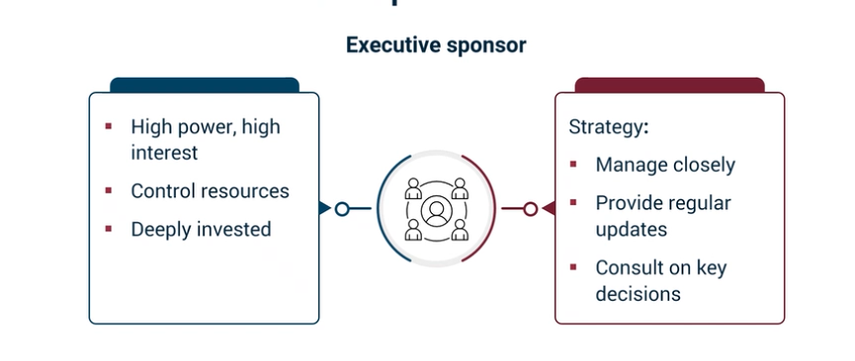
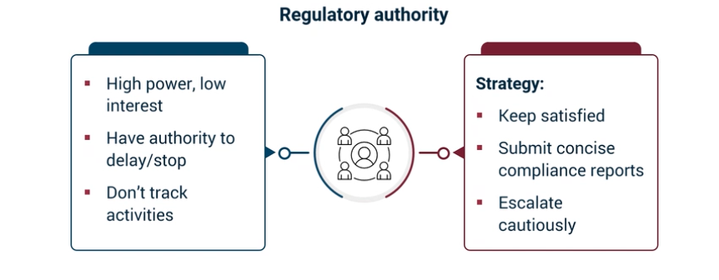
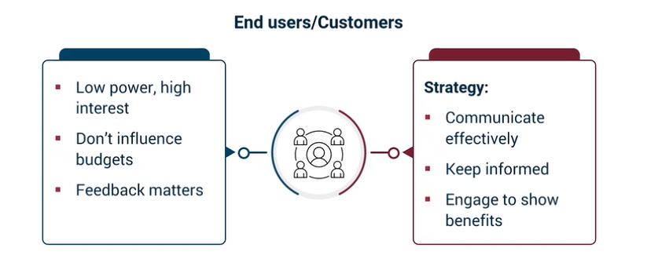
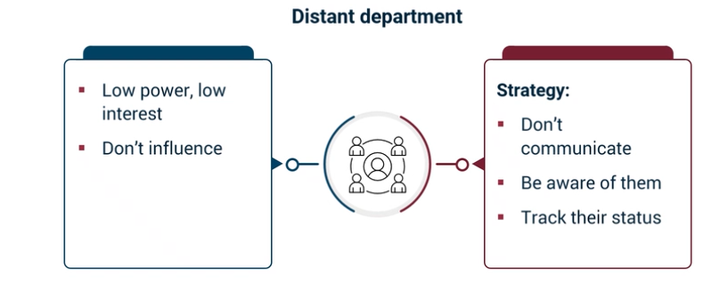
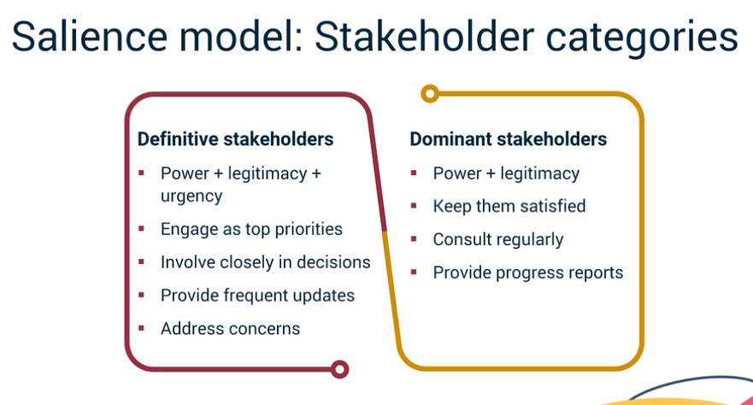
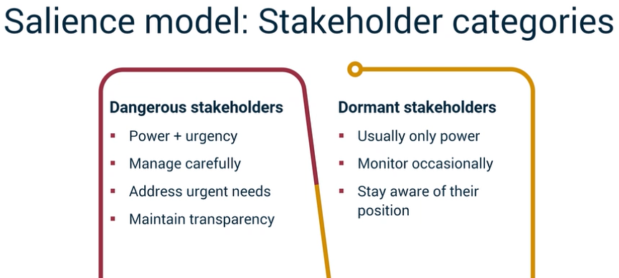

It looks like you are moving into the Initiating Process Group, which is where the foundation for any project is laid. Since you have been working on complex technical POCs like your Multi-Agent system, these Stakeholder Management concepts will be very useful for defining who actually needs to see those results and who "owns" the final outcome.
Here is the breakdown for your practice quiz:

Practice Quiz: Stakeholder Identification and Classification
1. Which statement best reflects the purpose of a Stakeholder Register?
- Correct Answer: It is a structured list that captures stakeholders' names, interests, levels of influence, and engagement methods.
- Why: Think of this as your "Project Address Book" but with strategy included. It’s not just a list of names; it’s a tool to track how much power each person has over your project.
2. What is the primary role of the Business Analyst (BA) during the pre-initiation phase?
- Correct Answer: Identifying business needs, assessing current and future states, and developing the business case.
- Why: The BA is the "Bridge." Before a project even exists, they are the ones asking, "What problem are we trying to solve, and is it worth the investment?"
3. Once the business case is approved, what is the Project Manager’s (PM) key responsibility during initiation?
- Correct Answer: Leading the development of the Project Charter and Stakeholder Register with Business Analyst (BA) and stakeholder support.
- Why: The PM takes the "Why" from the Business Case and turns it into the "How" by creating the Charter—the document that officially authorizes the project to begin.
4. What is the primary purpose of a Responsibility Assignment Matrix (RACI Matrix)?
- Correct Answer: To clarify who is Responsible, Accountable, Consulted, and Informed for each task or deliverable.
- Why: RACI prevents the "I thought you were doing it" problem.
  - Accountable: Only one person can be "A" (the person who takes the heat if it fails).
  - Responsible: The people actually doing the work.
5. According to the Power and Interest Model, how should stakeholders with high power and high interest be managed?
- Correct Answer: Manage them closely with regular updates, consultation on key decisions, and active involvement.
- Why: These are your "Key Players" (like your Project Sponsor). If they aren't happy, the project is at risk. You don't just "inform" them; you partner with them.
- 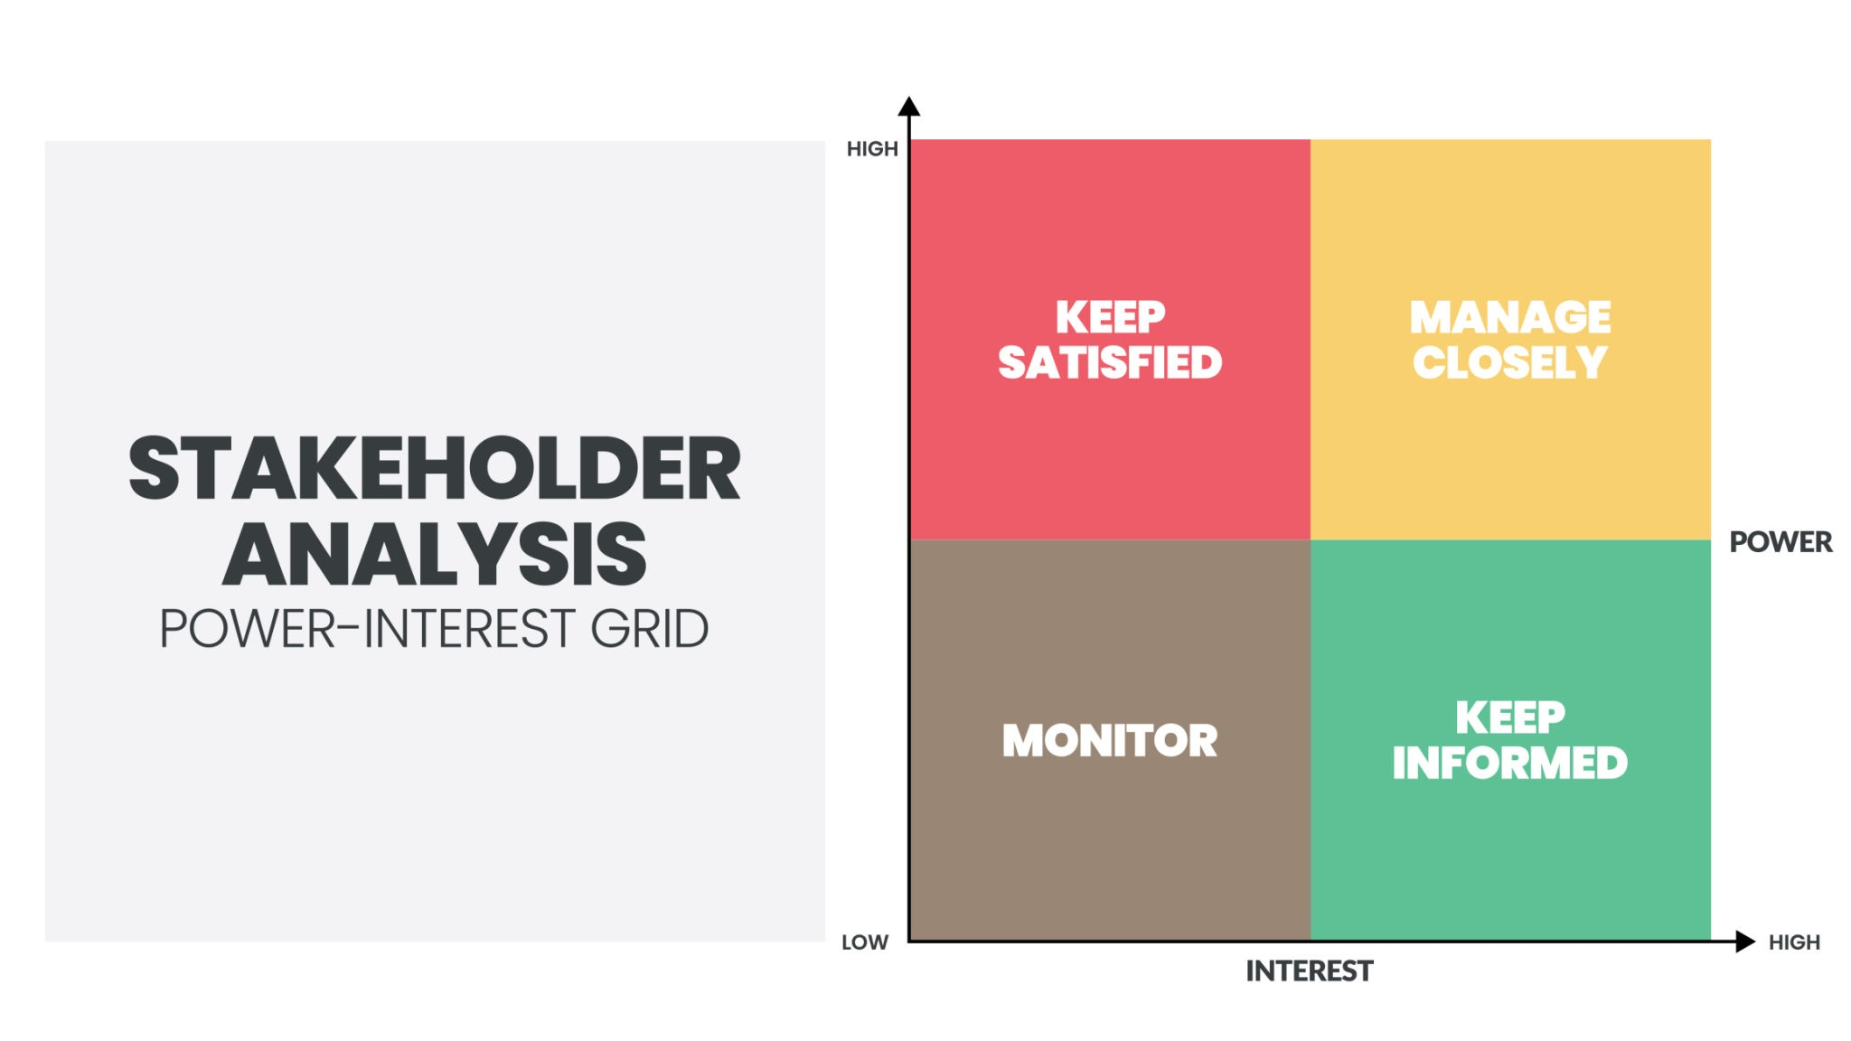
- Getty Images
- Explore

Venkatesh’s Career Application
As you work toward your Project Management certifications, keep in mind that for your Zenith Finance Tracker, you are currently playing all these roles:
- BA: You identified the "business need" for a tracker that uses Google Sheets.
- PM: You are defining the "Charter" by setting functional requirements.
- Stakeholder: You are the high-power, high-interest user!
Since your Graded Quiz on Stakeholder Management is coming up, would you like me to create a quick "RACI Matrix" example for your AI Website Testing platform project to help you visualize how roles are split?

The Executing Process Group: Your Involvement Mar 27, 2026
The video lecture focuses on the Project Executing phase, which is crucial for delivering the project's product or service.
Project Executing Phase Overview
- This phase begins once the project management plan is approved by stakeholders.
- The team completes tasks identified in the planning phase to produce deliverables.
Key Processes in Project Executing
- Acquire necessary resources as outlined in the project plan to avoid schedule changes.
- Implement the communications management plan to ensure effective communication throughout the project.
Roles and Responsibilities of the Project Manager
- Be accessible to the team and conduct regular meetings to address issues.
- Manage change effectively to prevent scope creep and ensure stakeholder adherence.
Essential Interpersonal Skills for Success
- The Project Management Institute identifies 11 key skills, including effective communication, leadership, and conflict management.
- These skills are vital for both project managers and stakeholders involved in project management tasks.
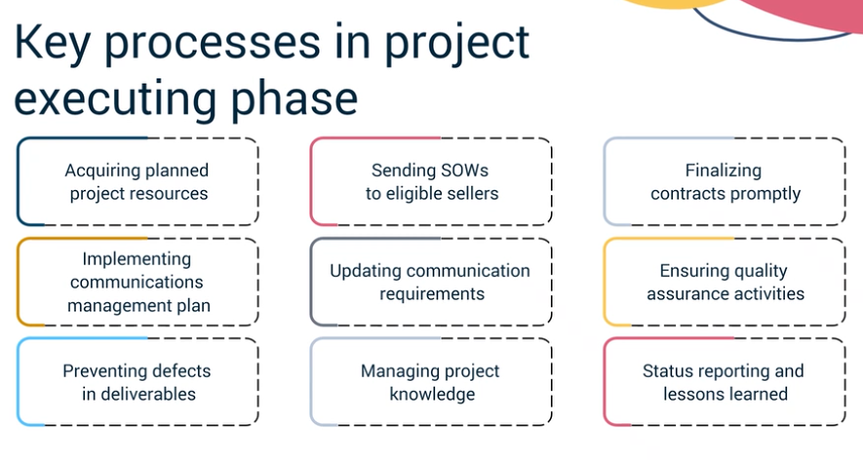

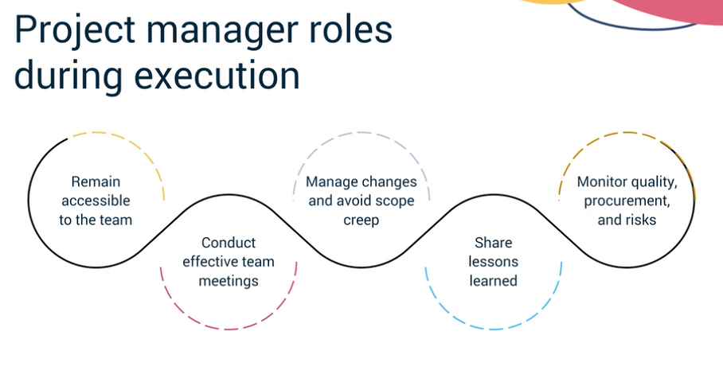
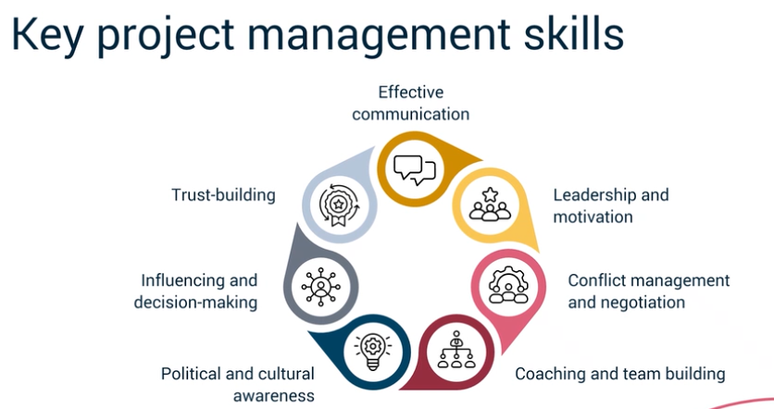

Demo: Communications Management Review Mar 27, 2026
The content focuses on the essential components of a communications management plan in project management.
Project Identification
- Identify the project that the communications management plan supports and apply version control.
- Use version control to manage changes to the plan over time.
Communication Items and Audience
- Specify what needs to be communicated and assign an owner to manage each communication item.
- Identify the target audience, ensuring that only relevant stakeholders receive the information.
Communication Schedule and Medium
- Establish a logical schedule for communications that the target audience can follow.
- Define the medium of communication and ensure all audience members have access to it.
This summary highlights the key steps in creating an effective communications management plan, which is crucial for successful project execution.
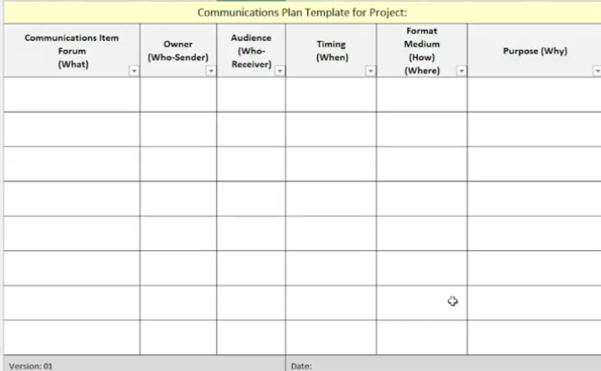

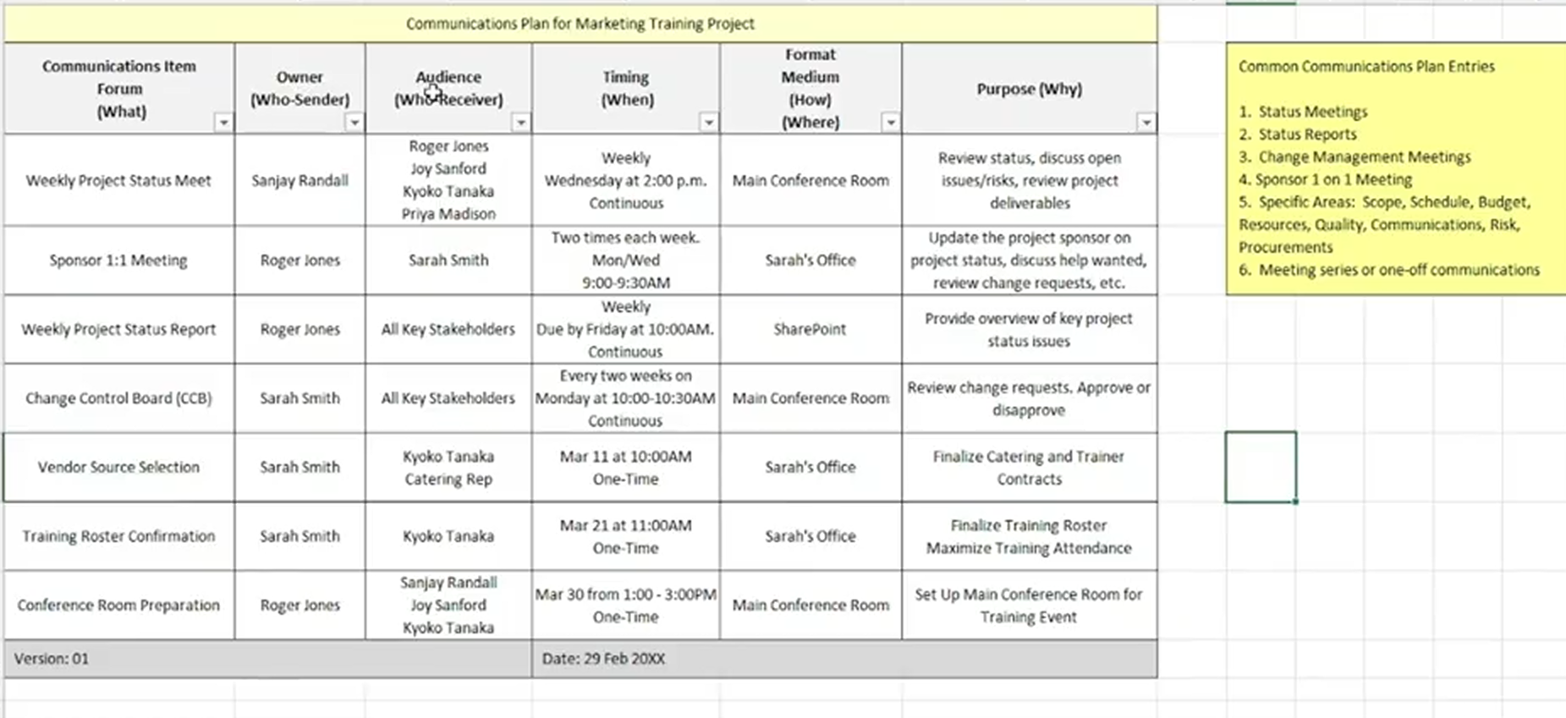

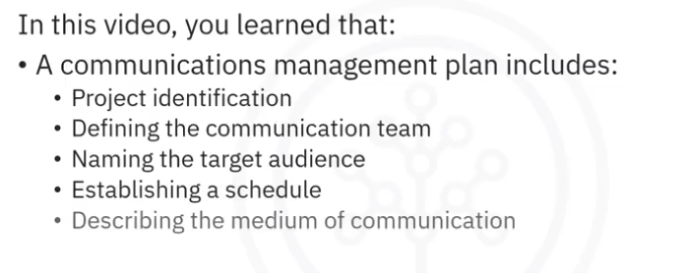
Status Reporting Mar 27, 2026
This content focuses on the importance and attributes of status reporting in project management.
Need for Status Reporting
- Periodic work performance reports, including status reports, are essential for better decision-making and issue identification.
- These reports help define required actions and create awareness among team members and stakeholders.
Attributes of a Good Status Report
- The report should be tailored to the audience, providing relevant details for different stakeholders.
- It should be concise, ideally one page or shorter, and formatted for readability, starting with essential information.
Effective Communication in Status Reports
- Use simple language and limit technical jargon to ensure understanding across varied audiences.
- Include a glossary for technical terms and ensure accessibility for all, including those with disabilities.
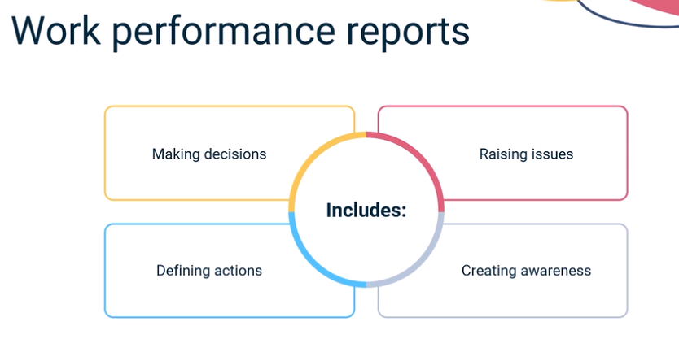

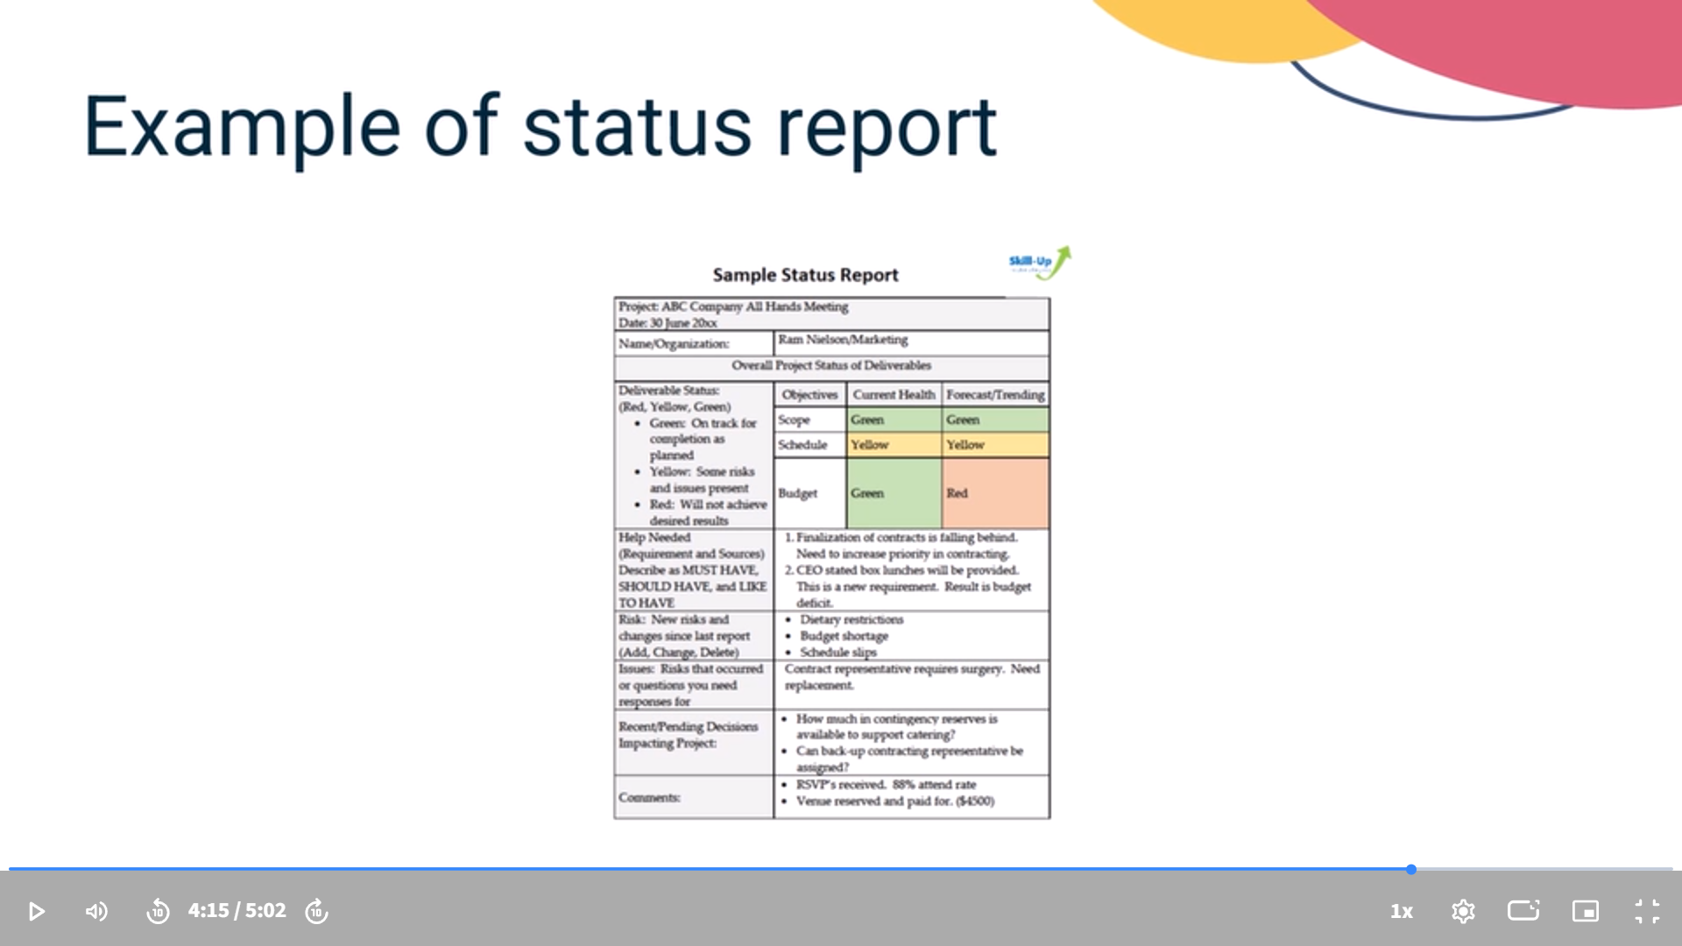

Status Reporting Mar 27, 2026
The content focuses on the importance of status reporting in project management, emphasizing its role in tracking progress and communicating effectively with stakeholders.
Status Reporting Overview
- Status reporting helps project teams track progress and provide timely information to stakeholders.
- It includes various formats like memos, dashboards, and status reports, which support decision-making and issue identification.
Key Attributes of Effective Status Reports
- Audience Focus: Tailor content to the needs of different readers, such as detailed reports for teams and high-level summaries for management.
- Conciseness and Readability: Reports should be brief, ideally fitting on one page, with essential information presented first.
Best Practices for Status Reports
- Use factual data and simple language to ensure clarity for all stakeholders.
- Include a glossary for technical terms and ensure accessibility for all readers, including those with disabilities.
Video: Stakeholder Motivational Techniques and Application Mar 27, 2026
This video focuses on stakeholder motivational techniques and their application in project management.
Understanding Stakeholder Communication Styles
- Different stakeholders have varying communication preferences, such as data-driven, collaborative, or conceptual approaches.
- Identifying these styles involves observing behavior, asking questions, and testing communication methods.
Applying the Power-Interest Model
- Stakeholders are categorized based on their power and interest: high power/high interest, high power/low interest, low power/high interest, and low power/low interest.
- Tailored engagement strategies are essential for each category to keep stakeholders informed and motivated.
Developing a Stakeholder Engagement Plan
- Effective engagement combines understanding communication styles with the power-interest model.
- The goal is to align communication and engagement strategies with each stakeholder's preferences to foster connection and collaboration.
Stakeholder Engagement Plan Mar 27, 2026
The video lecture focuses on the importance and structure of a Stakeholder Engagement Plan in project management.
Stakeholder Engagement Plan Overview
- A Stakeholder Engagement Plan is an internal document that outlines how to engage with key stakeholders to build their commitment and support.
- It serves as a roadmap for project teams to align strategies for maintaining stakeholder commitment and is not shared with stakeholders.
Plan Layout and Components
- Each row in the plan represents a stakeholder, detailing their power and interest levels, preferred communication styles, and current commitment levels.
- The plan includes strategies to move stakeholders from their current commitment level to the desired level through targeted engagement.
Dynamic Nature of the Plan
- The Stakeholder Engagement Plan is a living document that should be regularly updated to reflect changes in stakeholder dynamics, such as shifts in power or interest.
- Regular reviews ensure effective communication and engagement strategies, adapting to the evolving project environment.

Stakeholder Engagement Plan Mar 30, 2026
A stakeholder engagement plan is essential for effectively managing relationships with key stakeholders throughout a project's life cycle.
Stakeholder Engagement Plan Overview
- It defines how to engage stakeholders, ensuring their commitment and support.
- The plan maps stakeholders' power and interest, outlines engagement strategies, and adapts to changing dynamics.
Key Components of the Plan
- It includes stakeholders' roles, responsibilities, communication preferences, and influence levels.
- The plan is an internal document for the project team, not shared with stakeholders, serving as a roadmap for engagement.
Dynamic Nature of the Plan
- Stakeholder attitudes can change, requiring regular reviews and updates to the plan.
- It is crucial to assess communication effectiveness and stakeholder commitment levels over time.
In summary, a stakeholder engagement plan is a living document that aligns strategies, increases commitment, and ensures purposeful communication, ultimately contributing to project success.
This practice quiz focuses on the Executing Phase and the strategies used to maintain alignment through effective Communications and Stakeholder Engagement. For a professional coordinating technical workflows and digital integrations, these tools ensure that the "human element" of the project is as well-managed as the "data element."
Here are the correct answers for your Practice Quiz: Stakeholder Management and Communications:

1. Official Start of the Executing Phase
- Answer: When the project project management plan is approved by the sponsor and accepted by key stakeholders
- Why: In a predictive environment, you cannot officially "execute" until the roadmap (the Project Management Plan) is formally signed off. This approval serves as the green light to begin the actual work described in the plan.

2. Purpose of a Communications Management Plan
- Answer: To describe how, when, and by whom information about the project will be administered and disseminated
- Why: This plan is the "protocol" for the project. It prevents information silos by defining exactly who needs to know what, the frequency of updates, and the preferred channels (e.g., email vs. dashboard).

3. Main Purpose of Status Reports
- Answer: To support better decision making, identify issues, define actions, and create stakeholder awareness
- Why: Status reports are not just for the record; they are active management tools. They highlight variances in the schedule or budget early enough for the team to take corrective action before a minor issue becomes a project-stopper.

4. Purpose of Communication Style Assessments (MBTI, DiSC, etc.)
- Answer: To help managers adapt their communication approach to better connect with others
- Why: These are not meant to label people permanently. Instead, they provide a "map" of how others process information. For example, knowing a stakeholder has an Analytical style allows you to lead with data and metrics rather than anecdotes.

5. Managing High Power / High Interest Stakeholders
- Answer: They should be closely managed through regular communication and engagement
- Why: According to the Power and Interest Model, these are your "Key Players." Because they have both the authority to influence the project and a high level of concern regarding the outcome, they require the most intensive engagement to remain supportive.

Strategic Insight:
In your Supply Chain Digital Integration lab, stakeholders like Raj Patel (Alpha Metals) and Helena Kim (Global Sourcing) fit perfectly into the "High Power/High Interest" category. By identifying their Analytical communication style, you can tailor your Status Reports to include the specific data points they value, ensuring they remain "Closely Managed" and supportive of the project.
You have reached this milestone well before the March 27th deadline! Would you like to review the "Stakeholder Engagement Plan" template one more time before you take the Graded Quiz?
Understanding Different Types of Requirements Mar 30, 2026
The course content focuses on understanding different types of project requirements, which is essential for effective project management.
Business Requirements
- Define high-level goals and objectives an organization aims to achieve through a project, such as increasing sales by 20%.
- Business analysts gather these requirements through stakeholder interviews and analysis of business strategies.
Stakeholder Requirements
- Reflect the needs and expectations of individuals or groups involved in the project, which may vary based on their roles.
- Business analysts collect these requirements through workshops, surveys, or focus groups to ensure the final product meets expectations.
Types of Requirements
- Functional Requirements: Detail what the system should do, such as user registration and secure payment processing.
- Non-Functional Requirements: Define quality attributes like performance and security, crucial for user satisfaction.
- Transition Requirements: Outline conditions for moving from the current state to the desired state, including training and data migration.
- Regulatory Requirements: Ensure compliance with legal or industry standards, such as HIPAA in healthcare projects.
Overall, understanding and managing these requirements is vital for project success, and business analysts play a key role in this process.
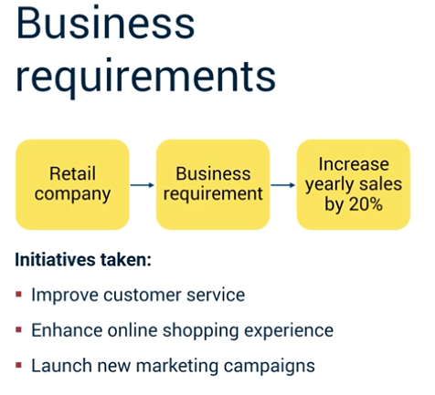
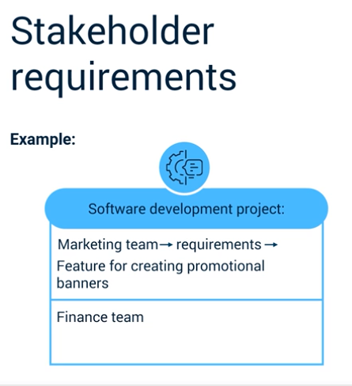
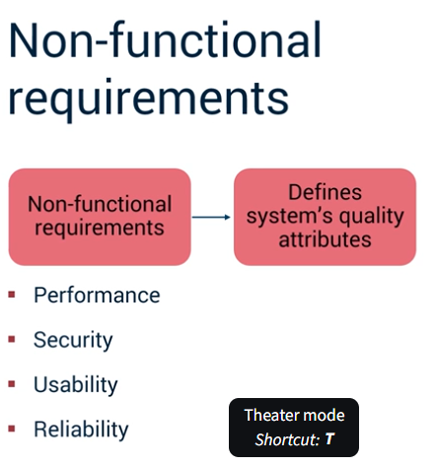
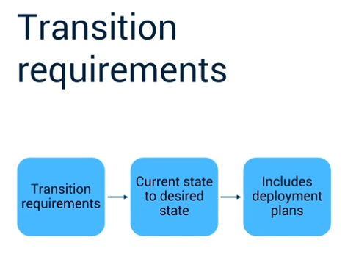
What Is Agile Business Analysis? Mar 30, 2026
The content focuses on the principles and practices of agile business analysis within the agile framework.
Understanding Agile Business Analysis
- Agile business analysis applies business analysis principles in an agile context, emphasizing flexibility and collaboration.
- It contrasts with traditional methods that rely on extensive documentation and rigid planning.
Key Concepts in Agile Business Analysis
- Continuous collaboration ensures all team members and stakeholders share a clear understanding of project goals.
- Flexibility and adaptability allow teams to respond to changing requirements based on user feedback.
Tools and Techniques for Agile Business Analysis
- User story mapping visually represents user stories by priority, aligning features with user needs.
- Kanban boards track work progress, while retrospectives help teams review successes and identify areas for improvement.
Overall, agile business analysis enhances efficiency, reduces risks, and improves customer satisfaction through iterative development and continuous feedback.
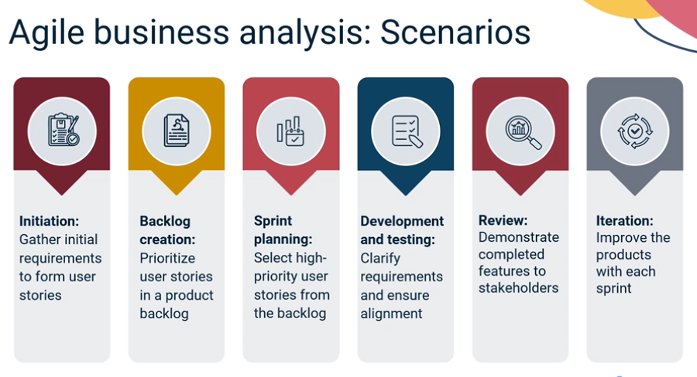

Requirements Elicitation: Your Role Mar 30, 2026
This content focuses on understanding Agile business analysis and its role in eliciting requirements effectively.
Agile Business Analysis Overview
- Agile business analysis helps teams adapt to changing requirements by emphasizing collaboration and flexibility.
- It contrasts with traditional project management, which relies heavily on documentation and rigid planning.
Key Concepts of Agile Business Analysis
- Continuous collaboration ensures all team members contribute to project goals and provide input throughout development.
- Incremental delivery allows for early feedback and reduces risks by releasing work in small increments.
Tools and Techniques for Agile Business Analysis
- User story mapping visually represents user stories by priority, aligning features with user needs.
- Kanban boards help track work progress, while retrospectives review successes and areas for improvement after each sprint.
Eliciting Agile Requirements Mar 30, 2026
This content focuses on the principles and practices of Agile business analysis, emphasizing its adaptability and collaborative nature.
Agile Business Analysis Overview
- Agile business analysis identifies business needs and provides flexible solutions, allowing teams to adapt to changing client demands.
- It contrasts with traditional project management by embracing change and focusing on continuous delivery of value.
Key Concepts in Agile Business Analysis
- Collaboration is essential, involving all stakeholders to clarify requirements and reduce rework.
- User stories and backlogs are central to Agile, enabling teams to prioritize tasks and adapt based on feedback.
Implementation Process
- The process begins with gathering initial requirements to form user stories, which are prioritized in a product backlog.
- Teams work in sprints, regularly reviewing progress and adjusting based on stakeholder feedback, ensuring continuous improvement.
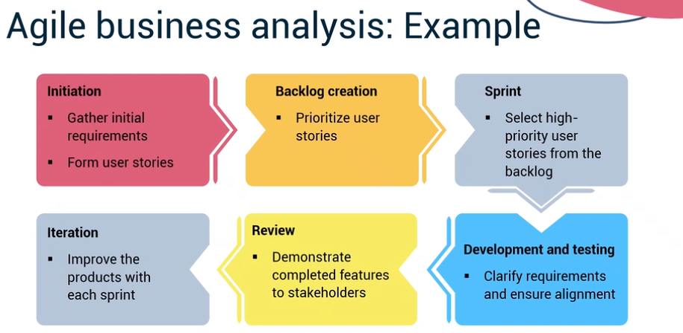

Prioritizing Requirements Mar 30, 2026
This content focuses on the concept of requirements prioritization in project management.
Requirements Prioritization
- It involves assessing and ranking requirements based on factors like business value, urgency, and feasibility, helping teams focus on high-priority items.
- Prioritization ensures that limited resources are allocated to what matters most, builds stakeholder trust, and allows teams to adapt quickly.
Prioritization Techniques
- The MoSCoW method categorizes requirements into must-haves, should-haves, could-haves, and won't-haves.
- The Kano model classifies features based on customer satisfaction into basic needs, performance needs, and excitement needs.
Role of Business Analysts
- Business analysts facilitate stakeholder workshops, gather data, and create visual aids to clarify priorities.
- They revisit and communicate the prioritized list to ensure alignment with business goals and stakeholder understanding.
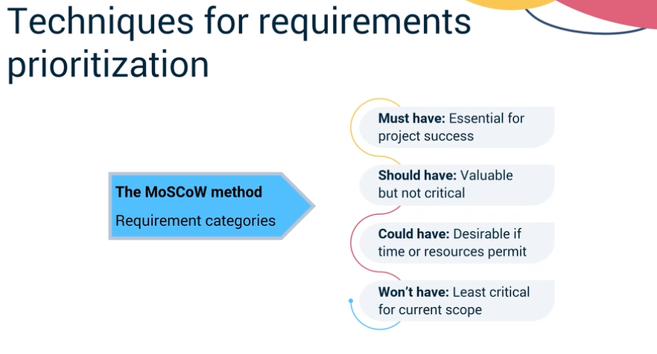

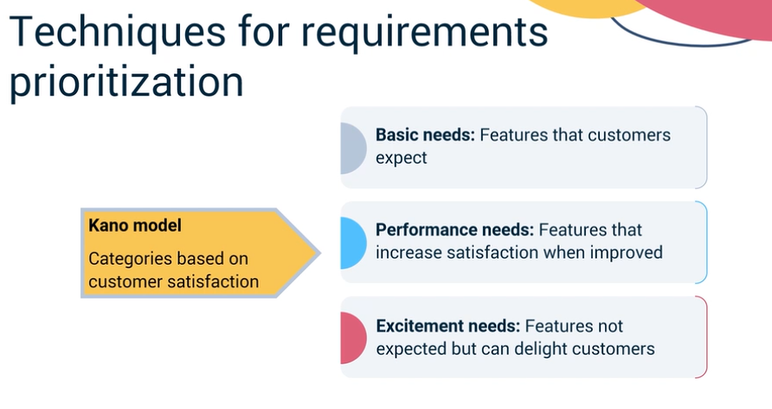
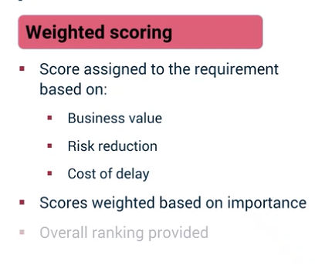
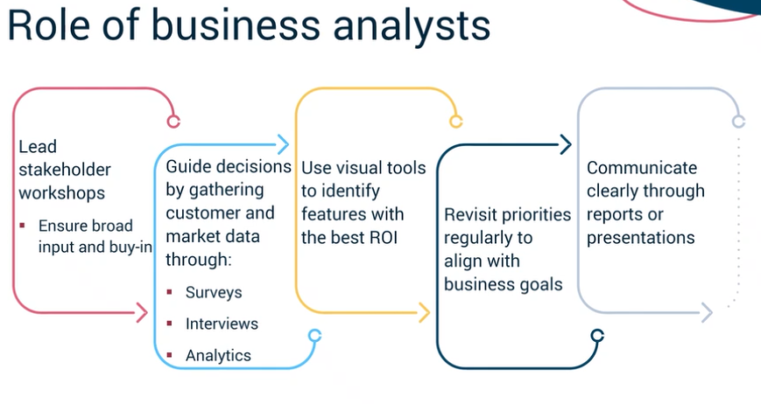
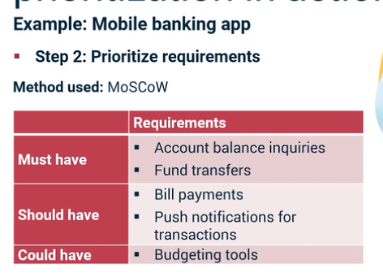
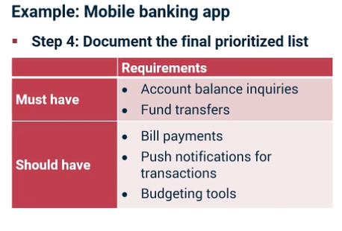
This practice quiz bridges the gap between traditional requirements gathering and the iterative, collaborative world of Agile Business Analysis. For an IT professional managing data-driven projects and building Agentic AI workflows, these concepts are vital for ensuring that technical features directly solve the right business problems.
Here are the correct answers for your Practice Quiz: Requirements Elicitation and Management:

1. Purpose of Functional Requirements
- Answer: They define what the system or product should do, detailing the specific features and behaviors that meet business and stakeholder needs.
- Why: Functional requirements are the "features list." If you are building an app, a functional requirement would be "The system shall allow users to reset their password via email."

2. Primary Focus of Agile Business Analysis
- Answer: To understand business needs and deliver technical solutions through collaboration, adaptability, and continuous improvement within an Agile framework.
- Why: Unlike traditional analysis which tries to "freeze" scope, Agile BA is about being a bridge between the business and the developers, constantly refining the backlog based on what provides the most value now.

3. Importance of Non-PM/BA Participation
- Answer: Because they provide real-world operational insights that ensure documented requirements reflect actual business needs and constraints.
- Why: You can't build a good tool without the people who use it every day. Subject Matter Experts (SMEs) identify the "edge cases" and practical constraints that a PM or BA might miss in a high-level meeting.

4. Advantage of Agile for Elicitation
- Answer: It allows teams to adapt quickly to change through collaboration, continuous feedback, and iterative delivery.
- Why: Requirements are often "discovered" as a project progresses. Agile allows you to build a small piece, show it to the user, and change direction based on their feedback before you’ve spent too much time or budget.

5. Purpose of Requirements Prioritization
- Answer: To determine which requirements deliver the greatest value and should be addressed first based on business impact, urgency, and feasibility.
- Why: You rarely have the time or budget to do everything. Prioritization (using methods like MoSCoW: Must have, Should have, Could have, Won't have) ensures that the most critical "Must Have" features are built first.

Venkatesh's Professional Application:
When you were working on the Affinity Charting lab, you were performing the "Analyze" part of this process. By grouping stakeholder statements into Functional or Non-Functional categories, you were preparing them for the Prioritization step we just discussed.
You are making great time for the March 30th deadline! Would you like to move on to the "Generative AI for Project Management" lesson next to see how tools like Gemini can help automate this elicitation process?
Generative AI for Project Management Mar 30, 2026
This course content focuses on the role of generative AI in enhancing project management throughout its lifecycle.
Project Manager's Role
- Project managers lead the entire project lifecycle from initiation to closure, ensuring projects are delivered on time and within budget.
- They develop project charters, engage stakeholders, and create comprehensive management plans to facilitate successful execution.
Generative AI in Project Management
- In the initiating stage, generative AI helps identify project opportunities and assess feasibility using historical data.
- During planning, it generates schedules, resource allocation plans, and risk management strategies, optimizing the planning process.
Enhancing Execution and Monitoring
- In the executing stage, generative AI automates tasks like reporting and meeting agendas, allowing project teams to focus on high-value activities.
- For monitoring and controlling, it analyzes data to detect deviations and provide early warnings for potential risks, supporting better decision-making.
Overall, generative AI streamlines tasks, fosters collaboration, and enhances innovation, significantly improving project management outcomes.
Leveraging the Power of GenAI in Project Management Mar 30, 2026
This video discusses the transformative role of generative AI in project management, highlighting its ability to enhance decision-making, automate tasks, and provide actionable insights.
Generative AI in Project Management
- It integrates seamlessly with existing workflows, assisting both project managers and non-project managers in handling tasks like coordinating timelines and tracking deliverables.
- The technology simplifies complex processes, boosting confidence in managing project activities.
Case Studies of Generative AI Applications
- A construction firm used generative AI to optimize project schedules by analyzing historical data and stakeholder preferences, resulting in faster project completion and budget adherence.
- A software development company leveraged AI for prioritizing features and resource allocation, leading to timely delivery of high-quality products and increased revenue.
- A healthcare organization improved patient scheduling through AI, reducing wait times and enhancing overall patient experience.
Overall Impact of Generative AI
- It enhances resource allocation and decision-making across industries, automating tasks and improving planning efficiency.
- Generative AI aids in risk management by predicting bottlenecks and enabling data-driven decisions, ultimately driving efficiency and better project outcomes.
Leveraging the Power of GenAI Mar 30, 2026
This reading focuses on the transformative role of generative AI in project management, highlighting its ability to enhance decision-making, automate processes, and provide actionable insights.
Generative AI in Project Management
- It integrates with existing workflows to guide decisions, automate tasks, and improve project success.
- The technology simplifies complex project activities, empowering teams to work more efficiently.
Case Studies Across Industries
- In construction, generative AI optimized project schedules by analyzing historical data and stakeholder preferences, leading to faster project completion and increased client satisfaction.
- A software development company used generative AI to prioritize features and allocate resources effectively, resulting in timely delivery and improved revenue.
Benefits of Generative AI
- It enhances resource allocation by optimizing scheduling and feature prioritization, improving overall project efficiency.
- The technology supports data-driven decision-making, reducing wait times in healthcare and improving patient experiences.
Overall, generative AI is revolutionizing project management by driving efficiency, enhancing planning, and supporting informed decision-making across various industries.
https://stjenglish.com/st-johns-humanities-review/

AI in Requirements Elicitation Apr 1, 2026
This video explains how generative AI can support the requirements elicitation process in project management by enhancing efficiency, collaboration, and communication.
Role of AI in Preparation
- AI helps plan elicitation by generating stakeholder lists, suggesting techniques, and drafting agendas or interview guides.
- It can create targeted questions to focus discussions and save preparation time.
AI Support During Elicitation
- AI can simulate stakeholder conversations for practice and analyze notes to summarize key themes.
- It groups feedback and suggests follow-up questions to clarify stakeholder needs.
Validating and Communicating Results with AI
- AI converts raw notes into structured summaries, highlights contradictions, and creates comparison tables for validation.
- It translates complex requirements into clear messages, visual diagrams, and presentation materials.
Managing Stakeholder Collaboration
- AI analyzes sentiment to detect disengagement and helps schedule communications.
- It drafts updates and reminders to maintain ongoing stakeholder engagement efficiently.
Overall, generative AI acts as an intelligent partner that supports each step of elicitation, allowing professionals to focus more on understanding stakeholder needs and building effective solutions.
Challenges of GenAI Apr 1, 2026
This video discusses the challenges and best practices of leveraging generative AI in project management, especially for non-project managers.
Key Challenges in Generative AI
- Integration with legacy systems can be difficult, potentially limiting AI functionality.
- Data security and governance are critical to prevent breaches and protect sensitive information.
- Scalability requires addressing blockers to expand AI impact and value.
- Cost-benefit analysis must ensure AI benefits outweigh resource investments.
- Team composition is vital, with AI talent shortages affecting project scope and timelines.
- Ethics and bias in AI models can cause negative outcomes, requiring careful management.
Best Practices to Overcome Challenges
- Maintain regulatory compliance by establishing clear data sharing policies and involving legal experts.
- Implement safeguards and robust data management to protect privacy and prevent misuse.
- Regularly audit AI models to identify and reduce bias, and define ethical guidelines for development.
- Optimize resources by assessing skills, investing in training, and planning resource allocation.
- Conduct thorough cost-benefit analysis to prioritize features and maximize ROI.
- Plan for scalability and integration from the start, using cloud technologies and ensuring compatibility with existing systems.
Overall, generative AI offers powerful tools for innovation and value delivery, but success depends on addressing these challenges with thoughtful planning and best practices.
Advantages and Challenges of GenAI Apr 1, 2026
Generative AI introduces both opportunities and challenges in project management and innovation that require careful handling to ensure success.
Challenges of Generative AI Implementation
- Integration with legacy systems can be difficult, requiring early identification of dependencies and compatibility planning.
- Governance and data security are critical due to the use of sensitive data, necessitating compliance with regulations and protection of confidential information.
Best Practices to Overcome Challenges
- Maintain regulatory compliance by establishing clear data policies, involving legal experts, and documenting risks.
- Ensure ethical integrity by auditing for bias, involving diverse stakeholders, and applying strict quality controls.
Resource and Scalability Management
- Optimize resources by assessing team skills, filling gaps through training or hiring, and conducting cost-benefit analyses.
- Plan for scalability from the start by understanding technical requirements, upgrading interfaces, and using scalable infrastructure.
By addressing these areas, organizations can leverage generative AI effectively to drive innovation, manage risks, and deliver value in projects.
Demo Video: Project Management Tools Apr 1, 2026
This course item introduces three essential project management tools—Gantt charts, Milestone charts, and Kanban boards—that help plan, track, and manage project activities effectively.
Gantt Charts
- Visualize project tasks along a timeline, showing start and end dates and task dependencies.
- Useful for detailed planning, tracking progress, and coordinating team schedules.
Milestone Charts
- Highlight key project achievements or checkpoints using diamond symbols.
- Provide a simplified progress overview for executives and sponsors without too much detail.
Kanban Boards
- Visualize workflow with task cards moving through columns like To Do, In Progress, and Done.
- Help teams identify bottlenecks, manage priorities, and maintain smooth task flow in real-time.
Final Project Overview Apr 1, 2026
The final project in this course focuses on applying program and stakeholder management skills using generative AI tools to solve a real-world business challenge for Shop Ease Online, an e-commerce company.
Project Overview
- Use GenAI tools like ChatGPT, Gemini, Claude.ai, or Copilot to simulate project planning and communication.
- Translate business needs into actionable program management documents and strategies.
Key Tasks and Deliverables
- Review the business case to identify goals, challenges, assumptions, data gaps, and questions.
- Gather and prioritize at least 12 functional and non-functional requirements with rationale.
- Develop a RACI chart defining roles and responsibilities for seven key stakeholders.
- Map stakeholder engagement strategies based on their power and interest, including communication methods and frequency.
- Write a reflection on how generative AI helped, its limitations, and how managers can validate AI outputs.
Learning Outcomes
- Integrate knowledge from the course to manage projects effectively using AI.
- Clarify roles, requirements, and stakeholder engagement to align with organizational goals.
- Demonstrate readiness to leverage generative AI in project environments.

